Kerry Suddes Training – Highlights
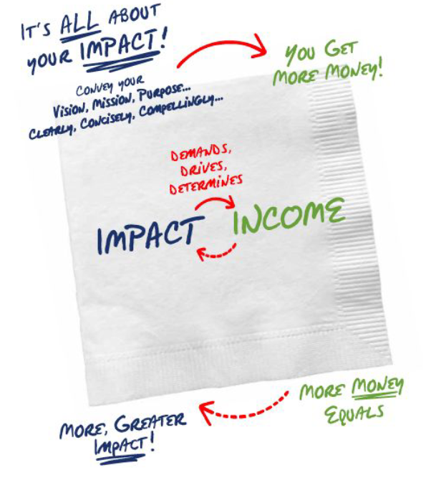

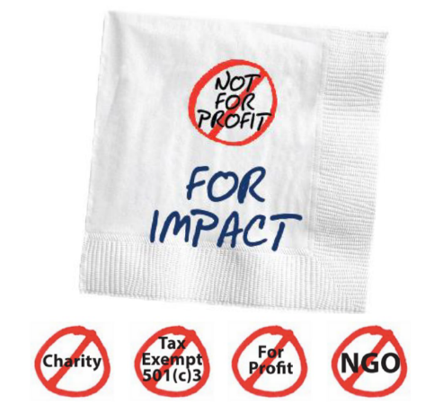
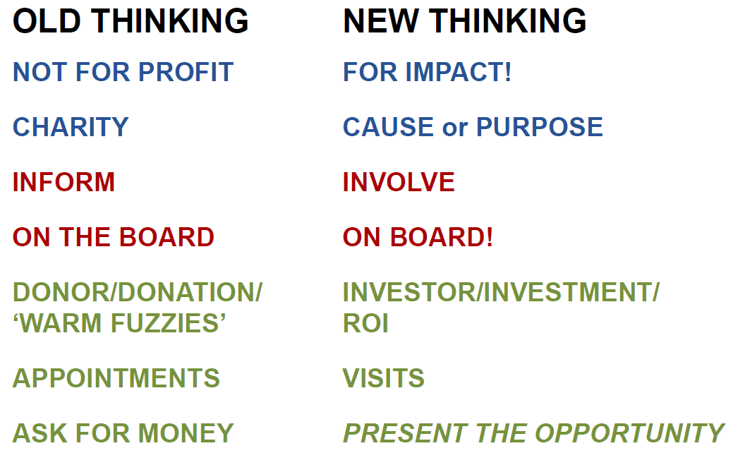

THE Fundraising Secret = Just Ask!
97/3 Return on Energy
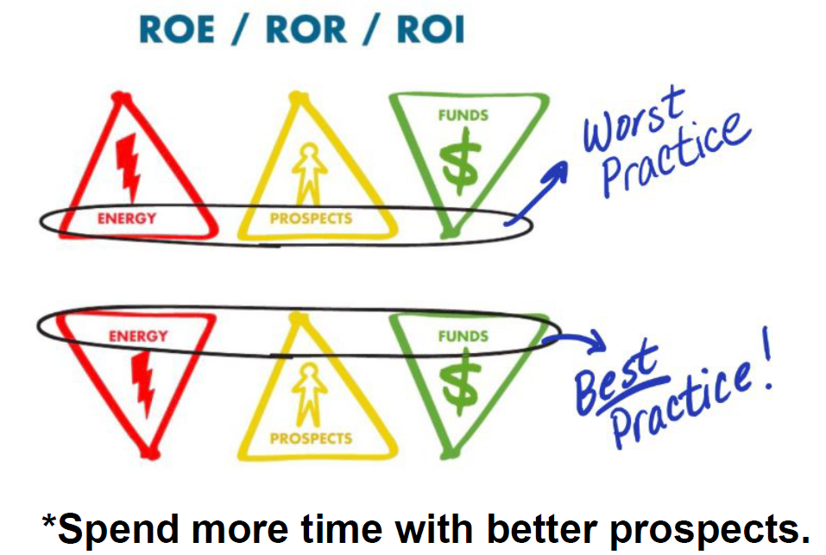

Have Altitude Awareness
30,000’ the WHY (Vision) Purpose
14,000’ the WHAT (Strategy) Priorities
3’ the HOW Plan
People will engage at the altitude of your choosing
3 Questions of Every Funder
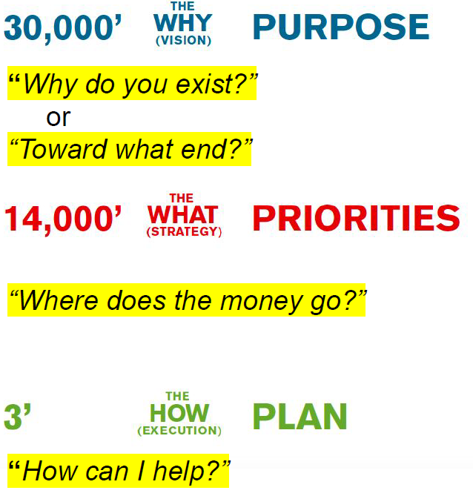

An Answer to “How can I Help”?
- Invest with a Commensurate Commitment
- Invite Others to Get Engaged
- Volunteer with Our Programs

Engagement
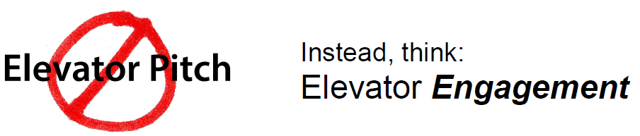
Creating Engagement
- Ask Questions
- Listen!
- Have a Visual

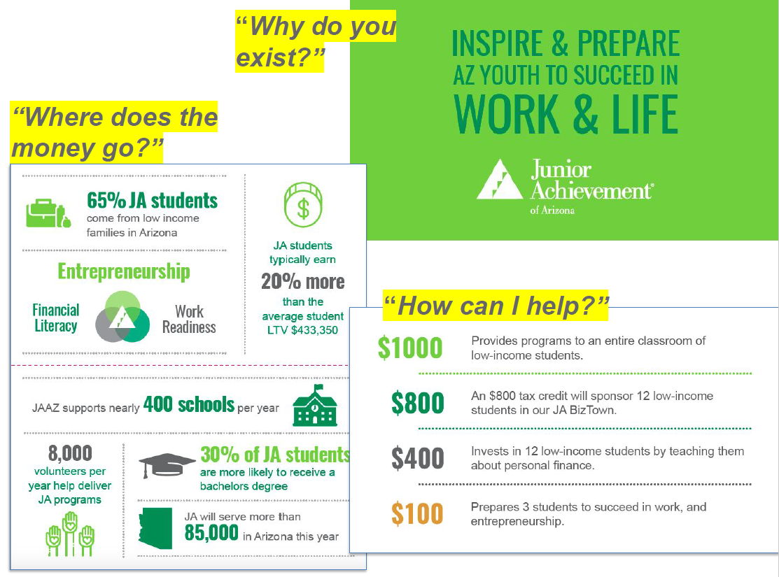

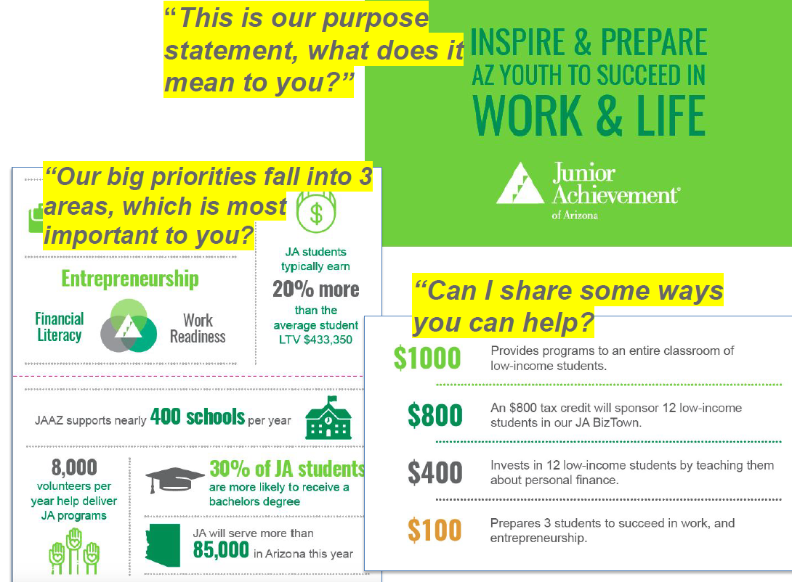
Defining Qualified Prospects

A Qualified Prospect Has:
- Relationship to Our Cause
- Capacity to Make an Investment

Prospecting Process

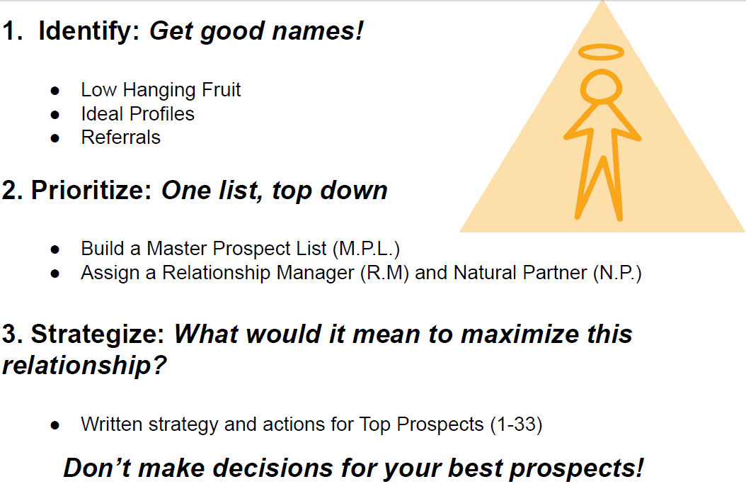

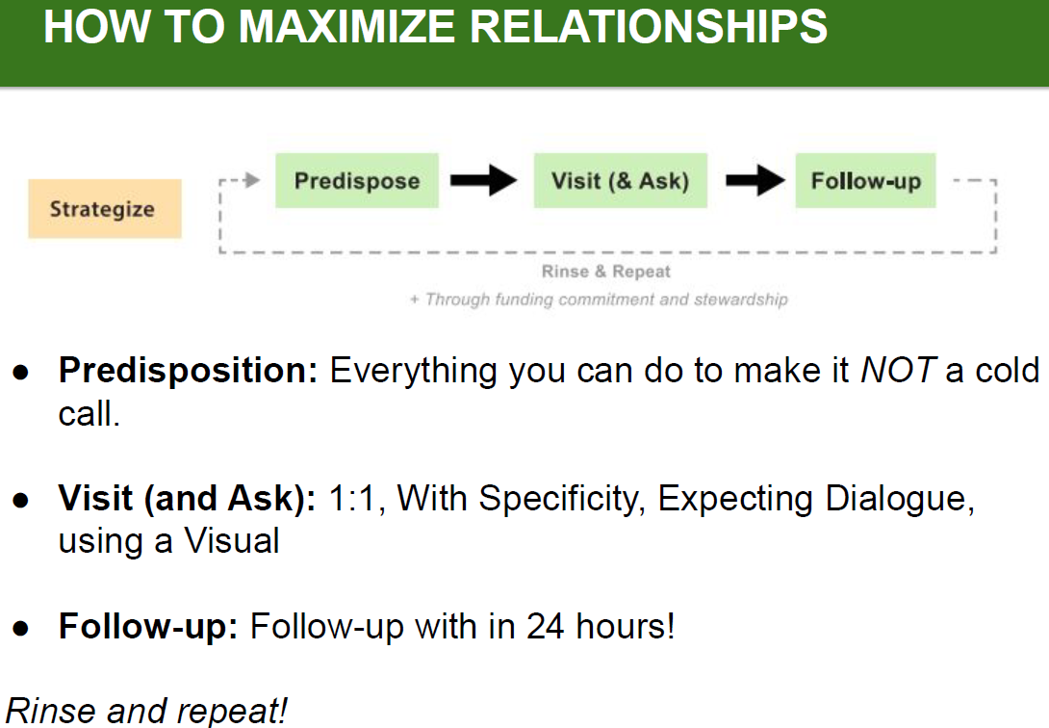

The Funding Role of a JA Ambassador
- Be a Champion for Junior Achievement and the youth we impact!
  - Thank you for your time and talent
  - We need your voice to advocate for an empower our young people – to equip them with the skills and knowledge to be successful and pursue their dreams
  - Help open doors to Qualified Prospects as a Natural Partner
- Invite Others to get engaged with JA
  - With a personal introduction to Sam, Chuck, Joss or other JA staff
  - Invite to volunteer with you
  - Invite to an event, or to tour JA BizTown
  - Work with other Board Members to identify 1-2 “new” Qualified Prospects per quarter
  - Review the Master Prospect List annually to see if there are people you can help predispose or introduce to the JA Development Team
- Invest with a commensurate commitment
  - Consider investing with a gift that is commensurate with your own personal capacity and passion for the impact

