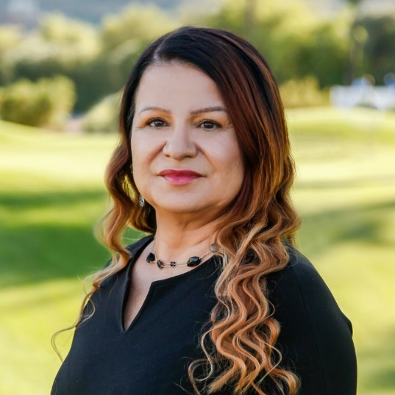
Lourdes Sierra
Vice President, Client & Community Relations
PNC
Seasoned executive focused on driving innovation within the corporate, public and non-profit sectors to deliver high impact partnerships and programs. 20+ years’ experience in financial services, corporate social responsibility (CSR), community development, financial literacy and asset-building, employee engagement, philanthropic investments and global communications. Passionate about helping low- and moderate-income communities connect to economic opportunity.
Twitter Handle: @LourdesPNC
Resolved. Resilient. Recharged. Latina. Champion of LMI communities. Passionate about music, the environment, football y futbol!

Experience
- Vice President, Client & Community Relations at PNC; 2019 - Present
- Vice President, Community Relations Officer at BBVA Compass; Sep 2014 - Nov 2019
- Community Development Manager at Desert Schools Federal Credit Union; 2012 - 2014
- External Communications Manager at Freeport-McMoRan Copper & Gold; Aug 2008 - Aug 2010
- Senior Marketing Manager at American Express; 1994 - 2007

Education
- Arizona State University -- Bachelors of Science, Marketing/International Business
- Arizona State University -- Masters of Art, Sustainability
- Arizona State University -- Bachelors of Art, Spanish/Latin American Studies
- University of Miami -- MBA in International Business

Volunteering
- LISC Phoenix LISC Phoenix -- Local Advisory Committee
- Keep Phoenix Beautiful -- Board Member
- Pete C Garcia Victoria Foundation – Board Member
- AZ Community Reinvestment Collaborative – Board Member
- Friendly House – Board Member

